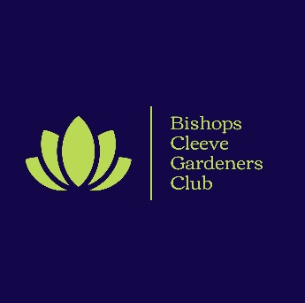
Bishops Cleeve Gardeners’ Club
Membership Cancellation Policy

- Membership Period
Membership of Bishops Cleeve Gardeners’ Club will run for 12mths from the 1 November each year, or for a pro rata number of months from the date that a membership application and pro rata payment is received.
- Cooling Off Period
All paid memberships will be subject to a 14-day cooling-off period from the date of renewal or purchase. If no member benefits have been used, any fees paid will be refunded in full to you once a written or emailed request to cancel your membership has been received within the 14-day cooling-off period. Your membership card must also be returned before any refund can be processed.
We will refund by the same method that we received the payment.
- Membership Cancellation
Members may cancel their membership to Bishops Cleeve Gardeners’ Club at any time but may not be eligible for a refund of fees already paid. Alternatively, members can lapse their subscription at the point of renewal through non-payment but will not be eligible for a refund of fees already paid.
Unless there are exceptional circumstances, you will not be eligible for any refund after the 14-day cooling-off period.
- Exceptions
Exceptions to this non refund policy is where Bishops Cleeve Gardeners’ Club is advised that a member is deceased or where the member has moved away from Gloucestershire. As the fees are paid in full at the start of membership or at the annual renewal point, a pro rata refund will be issued, minus any member benefits already received.
To cancel and receive a pro rata refund, a written confirmation of the request should be sent to bishopscleevegardeners@gmail.com
The membership card must also be returned and instructions to return this will be forwarded once the written request to cancel the membership is received.
- Where your membership is cancelled or withdrawn by the club
In very exceptional circumstances, your membership can be cancelled or withdrawn by the club. If this is the case, a pro rata refund may be given with deductions made for any members benefits already received in that membership year.
If your membership is withdrawn or cancelled by the Bishops Cleeve Gardeners’ Club, you will be notified in writing, via letter or email. Any refund will be made using the same method though which we received the membership payment.
This policy was last updated in February 2026

